An earthquake (also known as a quake, tremor or temblor) is the shaking of the surface of the Earth resulting from a sudden release of energy in the Earth's lithosphere that creates seismic waves.

Earthquakes can range in size from those that are so weak that they cannot be felt to those violent enough to propel objects and people into the air, and wreak destruction across entire cities. The seismicity, or seismic activity, of an area is the frequency, type, and size of earthquakes experienced over a period of time. The word tremor is also used for non-earthquake seismic rumbling.

At the Earth's surface, earthquakes manifest themselves by shaking and displacing or disrupting the ground. When the epicenter of a large earthquake is located offshore, the seabed may be displaced sufficiently to cause a tsunami. Earthquakes can also trigger landslides and occasionally, volcanic activity.

Causes of earthquakes Earth’s major earthquakes occur mainly in belts coinciding with the margins of tectonic plates. The most important earthquake belt is the Circum-Pacific Belt, which affects many populated coastal regions around the Pacific Ocean—for example, those of New Zealand, New Guinea, Japan, the Aleutian Islands, Alaska, and the western coasts of North and South America. It is estimated that 80 percent of the energy presently released in earthquakes comes from those whose epicentres are in this belt. The seismic activity is by no means uniform throughout the belt, and there are a number of branches at various points. Because at many places the Circum-Pacific Belt is associated with volcanic activity, it has been popularly dubbed the “Pacific Ring of Fire.”
A second belt, known as the Alpide Belt, passes through the Mediterranean region eastward through Asia and joins the Circum-Pacific Belt in the East Indies. The energy released in earthquakes from this belt is about 15 percent of the world total. There also are striking connected belts of seismic activity, mainly along oceanic ridges—including those in the Arctic Ocean, the Atlantic Ocean, and the western Indian Ocean—and along the rift valleys of East Africa. This global seismicity distribution is best understood in terms of its plate tectonic setting.

Natural forces Earthquakes are caused by the sudden release of energy within some limited region of the rocks of the Earth. The energy can be released by elastic strain, gravity, chemical reactions, or even the motion of massive bodies. Of all these the release of elastic strain is the most important cause, because this form of energy is the only kind that can be stored in sufficient quantity in the Earth to produce major disturbances. Earthquakes associated with this type of energy release are called tectonic earthquakes.
Tectonic earthquakes are explained by the so-called elastic rebound theory, formulated by the American geologist Harry Fielding Reid after the San Andreas Fault ruptured in 1906, generating the great San Francisco earthquake. According to the theory, a tectonic earthquake occurs when strains in rock masses have accumulated to a point where the resulting stresses exceed the strength of the rocks, and sudden fracturing results. The fractures propagate rapidly through the rock, usually tending in the same direction and sometimes extending many kilometres along a local zone of weakness. In 1906, for instance, the San Andreas Fault slipped along a plane 430 km (270 miles) long. Along this line the ground was displaced horizontally as much as 6 metres (20 feet). As a fault rupture progresses along or up the fault, rock masses are flung in opposite directions and thus spring back to a position where there is less strain. At any one point this movement may take place not at once but rather in irregular steps; these sudden slowings and restartings give rise to the vibrations that propagate as seismic waves.
Earthquakes have different properties depending on the type of fault slip that causes them (as shown in the figure). The usual fault model has a “strike” (that is, the direction from north taken by a horizontal line in the fault plane) and a “dip” (the angle from the horizontal shown by the steepest slope in the fault). The lower wall of an inclined fault is called the footwall. Lying over the footwall is the hanging wall. When rock masses slip past each other parallel to the strike, the movement is known as strike-slip faulting. Movement parallel to the dip is called dip-slip faulting. Strike-slip faults are right lateral or left lateral, depending on whether the block on the opposite side of the fault from an observer has moved to the right or left. In dip-slip faults, if the hanging-wall block moves downward relative to the footwall block, it is called “normal” faulting; the opposite motion, with the hanging wall moving upward relative to the footwall, produces reverse or thrust faulting.
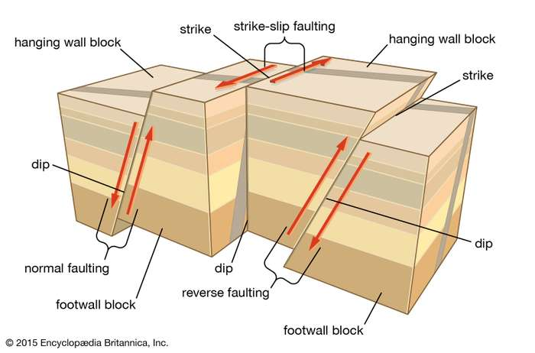
types of faulting in tectonic earthquakes In normal and reverse faulting, rock masses slip vertically past each other. In strike-slip faulting, the rocks slip past each other horizontally.

A separate type of earthquake is associated with volcanic activity and is called a volcanic earthquake. Yet it is likely that even in such cases the disturbance is the result of a sudden slip of rock masses adjacent to the volcano and the consequent release of elastic strain energy. The stored energy, however, may in part be of hydrodynamic origin due to heat provided by magma moving in reservoirs beneath the volcano or to the release of gas under pressure.
There is a clear correspondence between the geographic distribution of volcanoes and major earthquakes, particularly in the Circum-Pacific Belt and along oceanic ridges. Volcanic vents, however, are generally several hundred kilometres from the epicentres of most major shallow earthquakes, and many earthquake sources occur nowhere near active volcanoes. Even in cases where an earthquake’s focus occurs directly below structures marked by volcanic vents, there is probably no immediate causal connection between the two activities; most likely both are the result of the same tectonic processes.
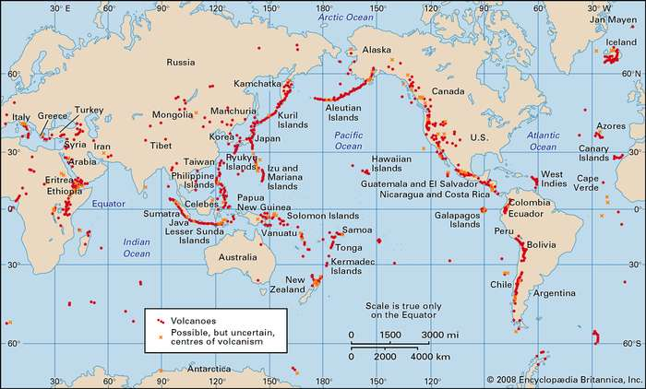
Volcanoes and thermal fields that have been active during the past 10,000 years.Encyclopædia Britannica, Inc.

Artificial induction Earthquakes are sometimes caused by human activities, including the injection of fluids into deep wells, the detonation of large underground nuclear explosions, the excavation of mines, and the filling of large reservoirs. In the case of deep mining, the removal of rock produces changes in the strain around the tunnels. Slip on adjacent, preexisting faults or outward shattering of rock into the new cavities may occur. In fluid injection, the slip is thought to be induced by premature release of elastic strain, as in the case of tectonic earthquakes, after fault surfaces are lubricated by the liquid. Large underground nuclear explosions have been known to produce slip on already strained faults in the vicinity of the test devices.

Reservoir induction Of the various earthquake-causing activities cited above, the filling of large reservoirs is among the most important. More than 20 significant cases have been documented in which local seismicity has increased following the impounding of water behind high dams. Often, causality cannot be substantiated, because no data exists to allow comparison of earthquake occurrence before and after the reservoir was filled. Reservoir-induction effects are most marked for reservoirs exceeding 100 metres (330 feet) in depth and 1 cubic km (0.24 cubic mile) in volume. Three sites where such connections have very probably occurred are the Hoover Dam in the United States, the Aswan High Dam in Egypt, and the Kariba Dam on the border between Zimbabwe and Zambia. The most generally accepted explanation for earthquake occurrence in such cases assumes that rocks near the reservoir are already strained from regional tectonic forces to a point where nearby faults are almost ready to slip. Water in the reservoir adds a pressure perturbation that triggers the fault rupture. The pressure effect is perhaps enhanced by the fact that the rocks along the fault have lower strength because of increased water-pore pressure. These factors notwithstanding, the filling of most large reservoirs has not produced earthquakes large enough to be a hazard.
The specific seismic source mechanisms associated with reservoir induction have been established in a few cases. For the main shock at the Koyna Dam and Reservoir in India (1967), the evidence favours strike-slip faulting motion. At both the Kremasta Dam in Greece (1965) and the Kariba Dam in Zimbabwe-Zambia (1961), the generating mechanism was dip-slip on normal faults.

Seismology and nuclear explosions In 1958 representatives from several countries, including the United States and the Soviet Union, met to discuss the technical basis for a nuclear test-ban treaty. Among the matters considered was the feasibility of developing effective means with which to detect underground nuclear explosions and to distinguish them seismically from earthquakes. After that conference, much special research was directed to seismology, leading to major advances in seismic signal detection and analysis.

Effects of Earthquakes

Shaking and ground rupture Shaking and ground rupture are the main effects created by earthquakes, principally resulting in more or less severe damage to buildings and other rigid structures. The severity of the local effects depends on the complex combination of the earthquake magnitude, the distance from the epicenter, and the local geological and geomorphological conditions, which may amplify or reduce wave propagation. Ground rupture is a visible breaking and displacement of the Earth's surface along the trace of the fault, which may be of the order of several meters in the case of major earthquakes. Ground rupture is a major risk for large engineering structures such as dams, bridges, and nuclear power stations and requires careful mapping of existing faults to identify any that are likely to break the ground surface within the life of the structure.

Soil liquefaction Soil liquefaction occurs when, because of the shaking, water-saturated granular material (such as sand) temporarily loses its strength and transforms from a solid to a liquid. Soil liquefaction may cause rigid structures, like buildings and bridges, to tilt or sink into the liquefied deposits. For example, in the 1964 Alaska earthquake, soil liquefaction caused many buildings to sink into the ground, eventually collapsing upon themselves.

Human impacts An earthquake may cause injury and loss of life, road and bridge damage, general property damage, and collapse or destabilization (potentially leading to future collapse) of buildings. The aftermath may bring disease, lack of basic necessities, mental consequences such as panic attacks, depression to survivors,and higher insurance premiums.

Landslides Earthquakes can produce slope instability leading to landslides, a major geological hazard. Landslide danger may persist while emergency personnel are attempting rescue.

Fires Earthquakes can cause fires by damaging electrical power or gas lines. In the event of water mains rupturing and a loss of pressure, it may also become difficult to stop the spread of a fire once it has started. For example, more deaths in the 1906 San Francisco earthquake were caused by fire than by the earthquake itself.

Tsunami Tsunamis are long-wavelength, long-period sea waves produced by the sudden or abrupt movement of large volumes of water—including when an earthquake occurs at sea. In the open ocean the distance between wave crests can surpass 100 kilometers (62 mi), and the wave periods can vary from five minutes to one hour. Such tsunamis travel 600–800 kilometers per hour (373–497 miles per hour), depending on water depth. Large waves produced by an earthquake or a submarine landslide can overrun nearby coastal areas in a matter of minutes. Tsunamis can also travel thousands of kilometers across open ocean and wreak destruction on far shores hours after the earthquake that generated them.
Ordinarily, subduction earthquakes under magnitude 7.5 do not cause tsunamis, although some instances of this have been recorded. Most destructive tsunamis are caused by earthquakes of magnitude 7.5 or more.

Floods Floods may be secondary effects of earthquakes, if dams are damaged. Earthquakes may cause landslips to dam rivers, which collapse and cause floods.

Prediction Earthquake prediction is a branch of the science of seismology concerned with the specification of the time, location, and magnitude of future earthquakes within stated limits. Many methods have been developed for predicting the time and place in which earthquakes will occur. Despite considerable research efforts by seismologists, scientifically reproducible predictions cannot yet be made to a specific day or month.

Forecasting While forecasting is usually considered to be a type of prediction, earthquake forecasting is often differentiated from earthquake prediction. Earthquake forecasting is concerned with the probabilistic assessment of general earthquake hazard, including the frequency and magnitude of damaging earthquakes in a given area over years or decades. For well-understood faults the probability that a segment may rupture during the next few decades can be estimated. Earthquake warning systems have been developed that can provide regional notification of an earthquake in progress, but before the ground surface has begun to move, potentially allowing people within the system's range to seek shelter before the earthquake's impact is felt.

Preparedness The objective of earthquake engineering is to foresee the impact of earthquakes on buildings and other structures and to design such structures to minimize the risk of damage. Existing structures can be modified by seismic retrofitting to improve their resistance to earthquakes. Earthquake insurance can provide building owners with financial protection against losses resulting from earthquakes Emergency management strategies can be employed by a government or organization to mitigate risks and prepare for consequences. Individuals can also take preparedness steps like securing water heaters and heavy items that could injure someone, locating shutoffs for utilities, and being educated about what to do when shaking starts. For areas near large bodies of water, earthquake preparedness encompasses the possibility of a tsunami caused by a large quake.

Preventive and Mitigation Measures When earthquake strikes a building is thrown mostly from side to side, and also up and down along with the building foundation the building structure tends to stay at rest, similar to a passenger standing on a bus that accelerates quickly. Building damage is related to the characteristics of the building, and the duration and severity of the ground shaking. Larger earthquakes tend to shake longer and harder and therefore cause more damage to structures

1 . For better understanding of all the possibilities of earthquake risk reduction, it is important to classify them in terms of the role that each one of them could play. Therefore, in the pre-earthquake phase, preparedness, mitigation and prevention are concepts to work on. Post-disaster, immediate rescue and relief measures including temporary sheltering soon after an earthquake until about 3 months later and re-construction and re-habilitation measures for a period of about six months to three years need to follow

2 . Structural No buildings can be made 100% safe against earthquake forces. Instead buildings and infrastructures can be made earthquake resistant to certain extent depending upon serviceability requirements. Earthquake resistant design of buildings depends upon providing the building with strength, stiffness and inelastic deformation capacity which are great enough to withstand a given level of earthquake-generated force. This is generally accomplished through the selection of an appropriate structural configuration and the careful detailing of structural members, such as beams and columns, and the connections between them. There are several different experimental techniques that can be used to test the response of structures to verify their seismic performance, one of which is the use of an earthquake shaking table (a shaking table, or simply shake table). This is a device for shaking structural models or building components with a wide range of simulated ground motions, including reproductions of recorded earthquakes time histories.

3. Nonstructural For getting the structural measures implemented with due earnestness, honesty of purpose and sense of compulsion host of non-structural measures in the form of policies guidelines and training have to be provided. Policy decisions about construction of structures with due approval from specified authorities have to be taken. The building codes etc have to be suitably formulated/amended and appropriately detailed and legal implications properly stated. Guidelines both for earthquake-resistant constructions have to be formulated with specifications about site selection, foundation, construction, materials and workmanship making involvement of specialist architects, trained engineer and masons mandatory.

4. Making all public utilities like water supply systems, communication networks, electricity lines etc. earthquake-proof.

5. Creating alternative arrangements to reduce damages to infrastructure facilities. Constructing earthquake-resistant community buildings and buildings (used to gather large groups during or after an earthquake) like schools, dharamshalas, hospitals, prayer halls, etc., especially in seismic zones of moderate to higher intensities.

6. Supporting R&D in various aspects of disaster mitigation, preparedness and prevention and post-disaster management.

7. Evolving educational curricula in architecture and engineering institutions and technical training in polytechnics and schools to include disaster related topics.

8. Preparation of disaster related literature in local languages with dos and don'ts for construction.

9. Getting communities involved in the process of disaster mitigation through education and awareness.

10. Networking of local NGOs working in the area of disaster management.

11. Post-Disaster Preventive Measures

Maintenance of law and order, prevention of trespassing, looting etc.

Evacuation of people

Recovery of dead bodies and their disposal.

Medical care for the injured

Supply of food and drinking water

Temporary shelters like tents, metal sheds etc.

Repairing lines of communication and information

Restoring transport routes

Quick assessment of destruction and demarcation of destroyed areas, according to the grade of damage

Cordoning off severely damaged structures that are liable to collapse during earthquakes.

